The COVID19's Effects on Tourism in Turkey

Ersan ŞEN

Ali Rahmi ATALAY

Ankara Yıldırım Beyazıt University

Prof. Dr. Halil Kemal Ilter

June, 2021

**Abstract**

Disasters on earth have always existed throughout history. Although there are different causes and types of these disasters, some of them occurred in the form of natural disasters and some of them occurred due to the behavior of people. These disasters sometimes left great marks in history and sometimes gave direction to the future. One of the biggest examples of these disasters has been epidemics. Many people have lost their lives due to various epidemics throughout history. One of these epidemics, which is often difficult for even the modern world to deal with, has emerged in the modern world under the name COVID19 and it is still ongoing. Although no definitive cure has yet been found, COVID19 continues to bring human lives to a standstill in many areas and continues to cause unpredictable damage in many sectors. One of the sectors that has suffered the biggest losses is the travel sector. In this sense, as in the whole world, COVID19 has had a serious negative impact on travel within Turkey and to Turkey. This situation deeply affects the tourism sector which is a major source of income for Turkey and it is causing serious losses on tourism. In this paper, we will try to explain and examine the effects and results of COVID19 on Turkish tourism with utilizing some statistical data and charts created using these data. In general, good analysis of the data and charts we receive and use of different sources will contribute to our research by helping us better see and understand the effects of epidemic disease.

**The COVID19's Effects on Tourism in Turkey**

Many epidemics have existed throughout history, and these epidemics have negatively affected human life and caused them to lose their lives during the periods when epidemics were effective. Sometimes these diseases have not been treated for long periods of time. These long periods have turned into difficult and desperate times for people. As it is known, one of these epidemics began as COVID19 at the end of 2019 and it affected the whole world in a short time. Therefore, today's modern world has been dealing with the problems and consequences caused by the pandemic and the pandemic itself for more than a year. Many areas, sectors and occupations have been caught unprepared for this situation and they have suffered unforeseen losses. Despite this, some sectors have grown rapidly with the help of pandemic conditions, while others have faced serious problems. In this sense, one of the sectors that has suffered huge losses is the tourism sector. Due to the geography of the country in which we live, it has a very important place in the tourism sector worldwide. To understand this situation clearly, we will say that we live in two major cities such as Istanbul and Antalya, that’s why we can see the negative effects of the pandemic very seriously. Due to the uncertainties in the provinces in which we are located, tourism has largely come to a standstill, and many institutions and organizations operating in this area are taking economic damage. As tourism, which is one of the largest sources of foreign exchange and income for our country, has been disrupted due to the pandemic, we have suffered great losses in economic terms both as the state and as citizens. Especially in tourism, oriented provinces such as Antalya, businesses are experiencing difficult times. For this reason, different solutions are being sought to overcome this situation with minimal damage.

When starting, if we need to give some information in order to better understand the issue, the geographical location of Turkey is an important resource for Turkey. Thanks to this resource, it provides many advantages to our country. For example, the geographical location of Turkey has been home to many civilizations in history. In addition, being surrounded by seas on three sides, containing four different seasons has increased the importance of Turkey in different kinds of fields such as travel, tourism and these features has made a great contribution to the development of the country in that areas. For example, someone who wants to examine the Byzantine period can get a lot of information about this period with a trip to Istanbul. A person who lives in cold countries during the summer period can enjoy the hot summer period with a trip to the Antalya region. Different tastes found in different parts of our country also constitute an alternative for foreign people. As we can understand from these and similar examples, the cultural diversity that Turkey has can create a tourist area for everyone. In addition, the two cities that we have given as examples have a significant share in the Turkish tourism sector. According to data from the last year before the pandemic (2019), about 62 percent of tourists staying in Turkey chose Antalya province. After that, Istanbul comes with about 17 percent.

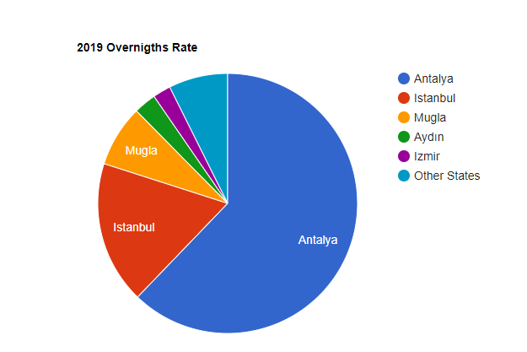

In the chart above, we see the distribution rate of the main provinces that tourists prefer to stay in in 2019. On the other hand, the epidemic conditions that emerged at the end of 2019 affected many different areas around the world, as well as deeply affected the Turkish tourism sector. In this sense, the effects of the COVID19 epidemic on Turkish tourism and some of its consequences will be discussed in the following sections.

In order to address how the pandemic period affects tourism, we have conducted various studies and obtained some published statistical data, and the charts we have created using these data will guide us to better understand the subject. First, we can see below the number of tourists who came to our country in the last 10 years and the amount of change compared to the previous year.

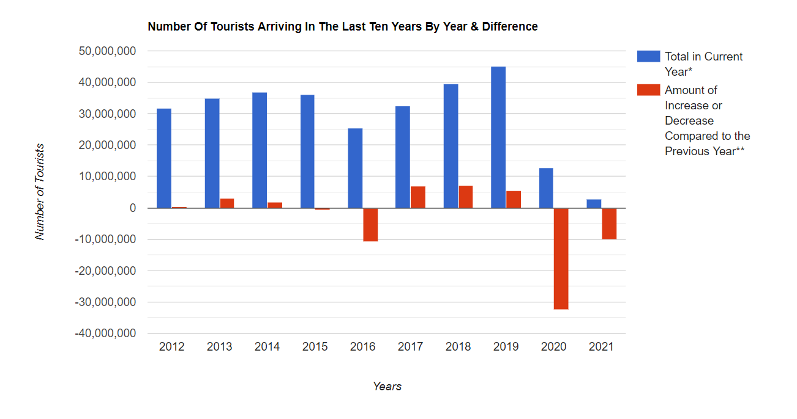

In the column chart above, the number of tourists coming to our country in general shows an increase with the exception of 2016**[1]**. Due to the epidemic at the end of 2019, countries have taken some measures to prevent the spread of the epidemic and protect against the virus. For example, temporary closure of borders, mandatory quarantine for entry and exit to countries etc. Under these conditions, tourist activities between countries were also suspended with the motto “human health first”. As a result, a table like the one above appeared.

In the previous paragraph, we looked at the data of the last 10 years. In this point, we will look at the situation from another point of view which is comparing the total number of tourists for two years before the pandemic and the total number of tourists for two years after the pandemic (one year and three months, since we are still in 2021).

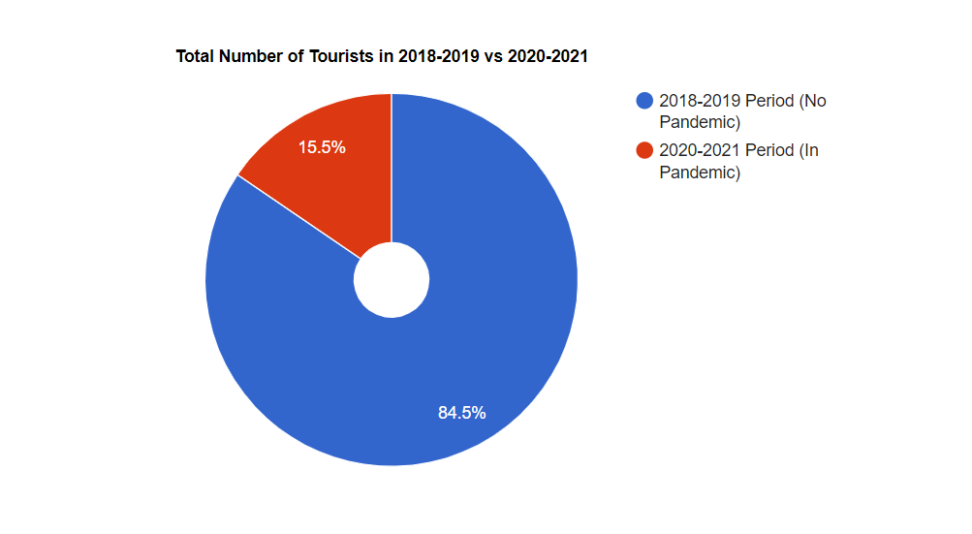

Looking at the graph above, we can see that the period before the pandemic had the largest area in the pie chart (blue area). Our total number of tourists in the period of 2018-2019 represented by this blue area is approximately 85 and a half million. In the period 2020-2021, which is the post-pandemic period (red area), only about 15 and a half million people visited our country. Assuming that there was no pandemic and there were no extreme conditions, the distribution of the blue and red areas on the chart should be close to each other (for example, 49% - 51% or 45% - 55%). But as a result of the conditions we are in, we have the values on the chart, and this is proof of how the number of tourists is seriously declining.

As we go a little further, we continue to examine data in a general-to-private way to get clearer ideas. For this purpose, in the first four months of the last four years, we compared the tourists who came to our country for tourism purposes according to the relevant months.

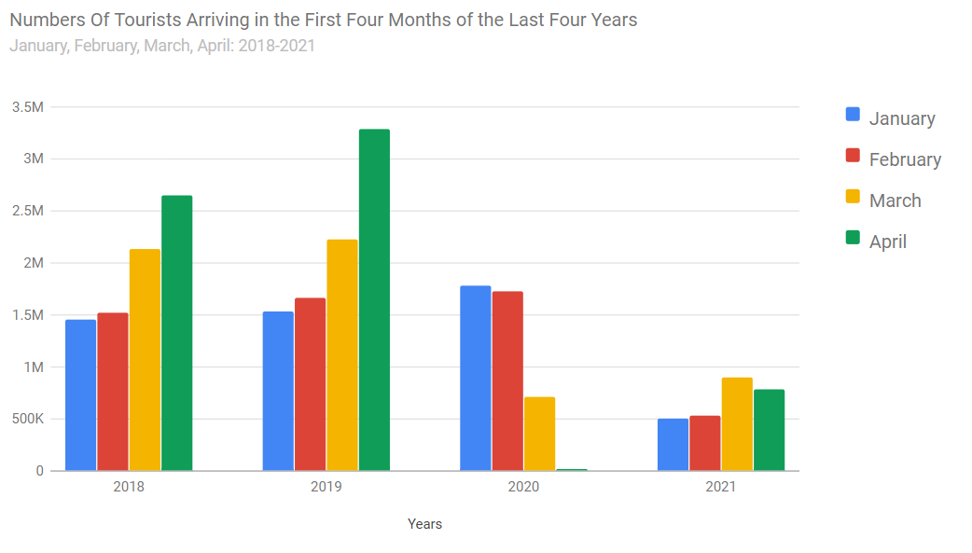

In the chart given above, we can clearly see the data of the first four months of the relevant years. As we mentioned earlier, when we look at the distribution of the months in 2018-2019, we can see that the ratio is maintained. In fact, we can say that the similarity continues in the first three months of 2020. As is known, COVID19 came to our country in March 2020. This is the main reason for the sharp decline in March 2020. Because of the reasons we have given before (closure of the borders etc.), we can also see this clearly in our data. In 2021, we can observe an increase in March compared to 2020. The reason for this increase can also be explained as follows: as a result of rapidly developing vaccine studies around the world, the emergence of vaccines that are yet to be developed but ready for use, and countries quickly create their own vaccination programs, vaccinate their populations, and depending on this situation, some measures that were sharply implemented in the previous year have been relaxed (for example, opening border entrances and exits etc.). If the measures taken work, it is expected that the numbers will increase again in the coming years.

In this part, we will look at the distribution of the number of tourists who came to our country in the last four years according to the countries in which they came. Below are the twelve countries that send the most tourists.

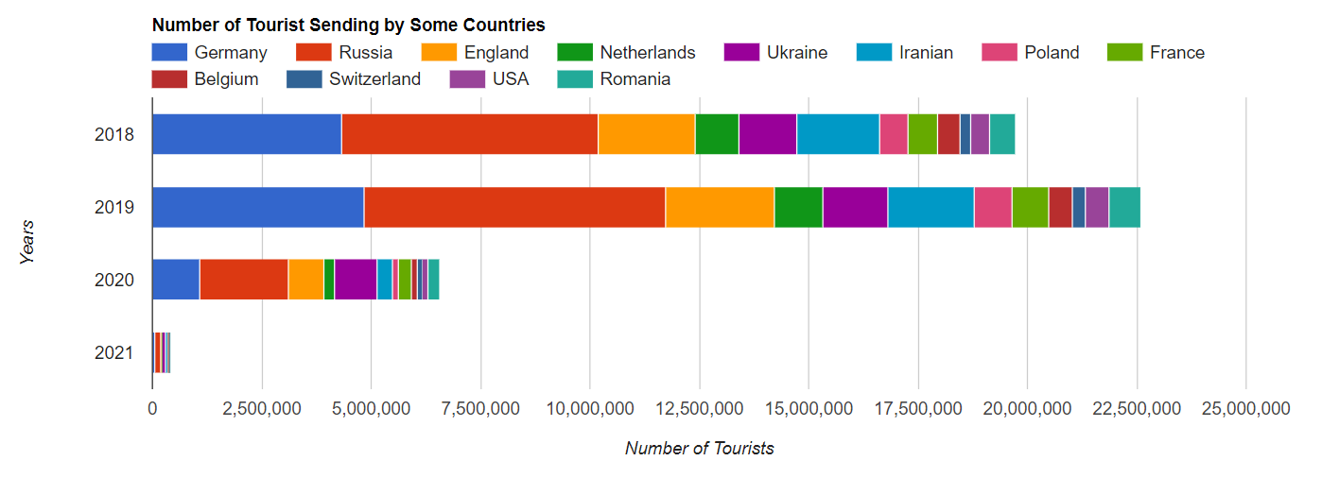

As can be seen in the chart above, we can see the distribution of tourists from various countries. First, a serious decline is observed in 2020. The reason for this, as mentioned earlier, is COVID19 which started in 2020 and it still continues its influence. We can clearly say that the number of tourists has fallen from twenty-two and a half million to about seven million. In addition, looking at the chart, we can see that the top three places in the ranking of the total number of tourists based on countries are generally Germany, Russia, and the United Kingdom. Although these countries are in the top three, the decline in the number of tourists in these countries cannot be ignored.

In the previous paragraph, we examined the number of tourists from twelve countries in the last four years. Now we want to go down to a little more special and examine the top five countries that have sent the most tourists to our country in the last four years. If we first need to start with 2018, the graph of the data for 2018 is as follows:

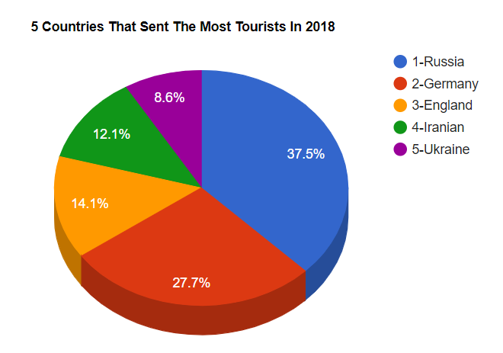

The distribution for 2018 is given above. The first 5 countries are as follows. (Russia, Germany, England, Iranian and Ukraine)

The graph of the data for 2019 is as follows;

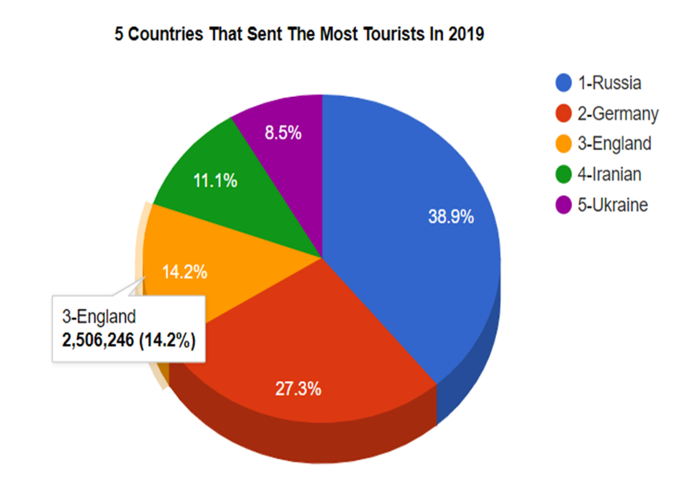

The distribution for 2019 is given above. The significance of this year is the last year before the pandemic. The first 5 countries are as follows. (Russia, Germany, England, Iranian, and Ukraine)

The graph of the data for 2020 is as follows;

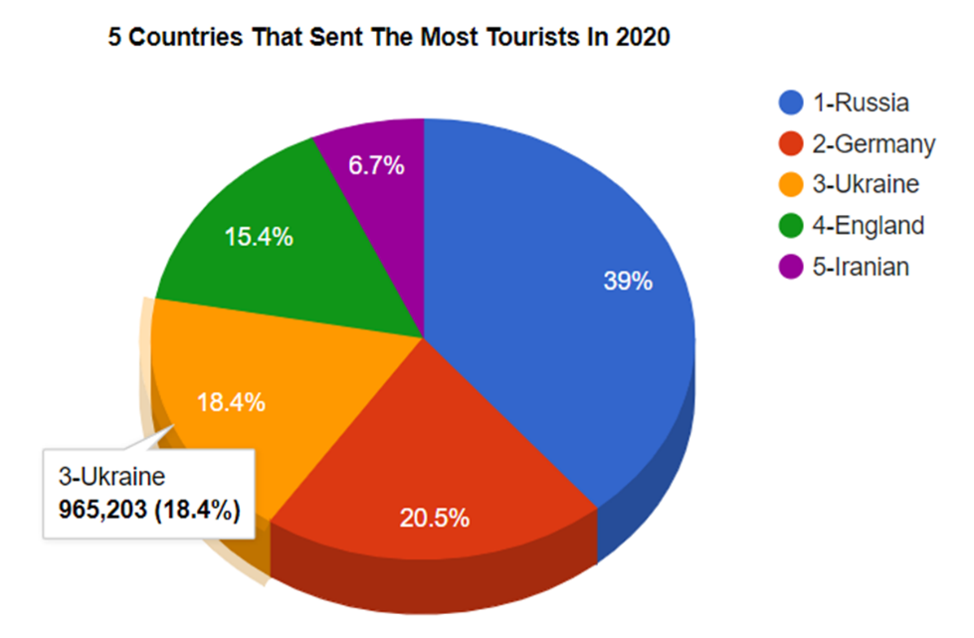

The distribution for 2020 is given above. The importance of this year, the pandemic started this year. The first 5 countries are as follows. (Russia, Germany, Ukraine, England, and Iranian)

The graph of the data for 2021 is as follows;

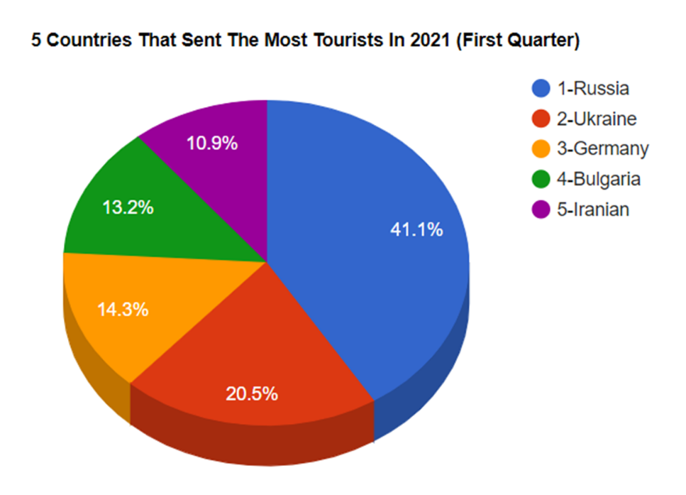

The distribution for 2021 is given above. We are still living in this year and the pandemic continues. As can be seen from the title, only the first quarter data. The first 5 countries are as follows. (Russia, Ukraine, Germany, Bulgaria, and Iran

During the pandemic process, there were some changes in the rankings compared to the period before the pandemic. The reason for these changes is some failures in countries' struggles with COVID19 in some periods (mutation of viruses, planning errors etc.). For example, the England mutation that occurs at there, mistakes made throughout the process management in Iran.

In this part, we will consider the distribution of tourists coming to our country according to the seasons. As is known, tourism activities in our country generally take place in summer. This mobility continues into the autumn season.

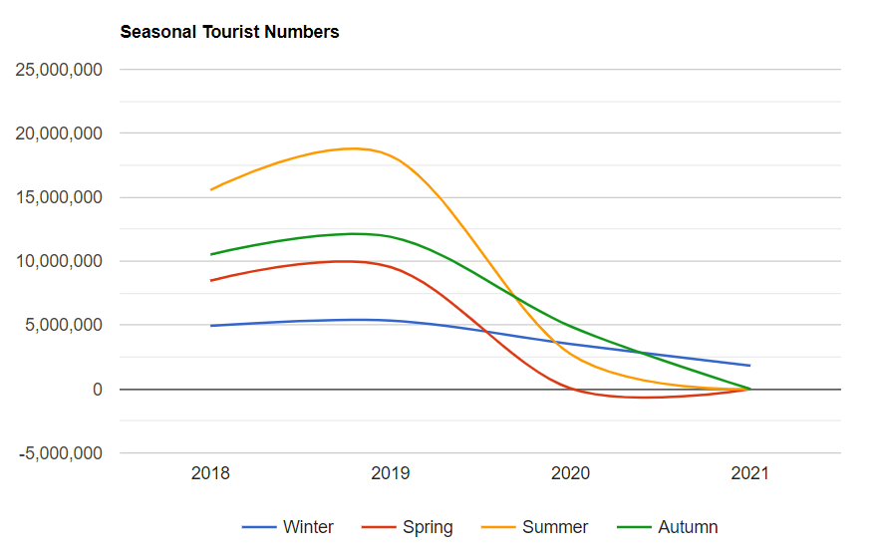

As can be seen from the graph, we can also observe the decline caused by the pandemic here. In particular, the decline in the summer and spring seasons of 2020 shows itself very sharply. Since these periods are the period of the emergence of the pandemic, the effect of uncertainties has an important place in this decline. Looking at the graph, there is a situation that attracts attention. The winter period also saw a decline, but this decline was not as much as expected. We can explain the reason for this as follows; there are many options in Turkish tourism such as marine tourism, cultural tourism, nature tourism etc. One of these options is health tourism. Turkey has a proven success in the health sector and has a very well-trained and specialized doctor staff in its field. Many visitors from both European countries and Middle East countries come to the country to take holidays and receive medical services. In some operations, since hot air has a negative effect on the treatment process after the operation, tourists who come on vacation for such operations make their visits in winter for this reason. As can be seen from the chart, there was less fluctuation during the winter period.

Now we will consider the effects of the epidemic on the amount of income and expenses in tourism. First, we see below the income and expenses of tourism in the last seven years.

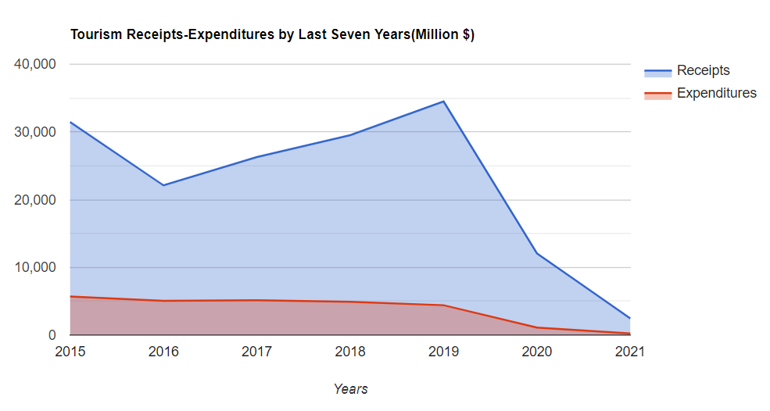

As can be seen from the chart, there is a stable and bullish progress except 2016. However, Turkey, which had to impose closure restrictions due to the pandemic in 2020, experienced a very significant decline in tourism revenues and revenues fell to about $ 13 billion. In addition, there is a decrease in our tourism spending. In light of this information, if we go more specifically and examine the first quarter data of the last four years, we can see these amounts in the chart below.

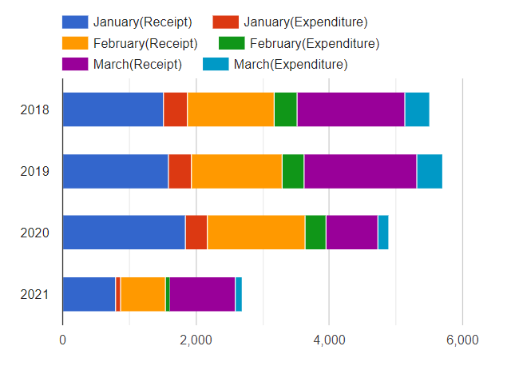

On the chart, 2020 saw normal progress until the third month, while march experienced a significant decline compared to the previous years. When we look at the march 2021 data, we can see that the value is maintained close to the 2020 values, while we expect a decline in the current pandemic conditions.

In the next chart, we want to address the status of tourism agencies. In the chart below, the number of tourism agencies in the last six years and their rates according to the amount of increase in the previous year are given.

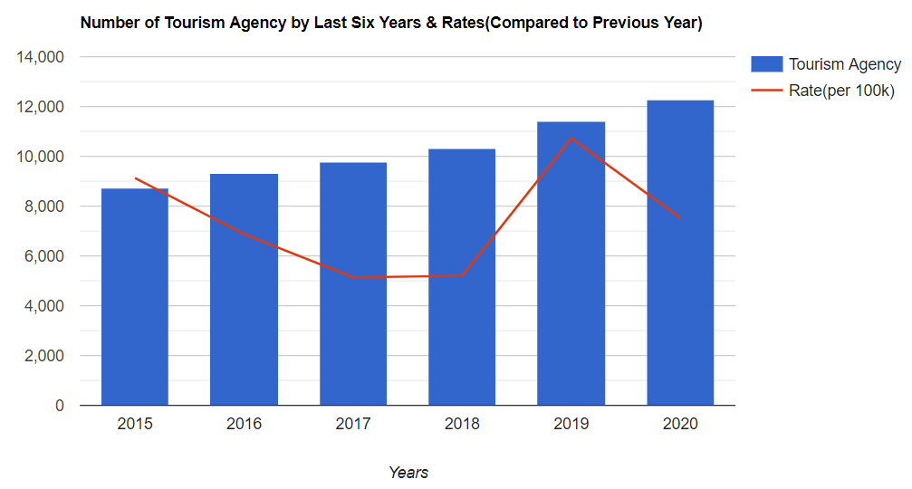

Looking at the chart, the number of agencies in the tourism sector remains despite the events in 2016 and the pandemic conditions that began in 2020. This result surprised us at first, but especially for the pandemic period, there was no epidemic yet in the first months of 2020, and since the businesses that opened were licensed during this period, it may have shown artificial growth in the chart (in data). In addition, since the pandemic has just begun in 2020, it is likely that such businesses will have enough resources to cover their own expenses. In addition, the relaxation of measures taken in the summer of 2020 in some local areas has given tourism some mobility. In this way, we can explain the reason why the number of tourism agencies in the chart has not decreased. We can see a slowdown in the opening rate in 2020 compared to the previous year, indicated by a red line on the chart. As part of this information, if we also consider the number of enterprises in the tourism sector and the number of beds, we have a chart as follows.

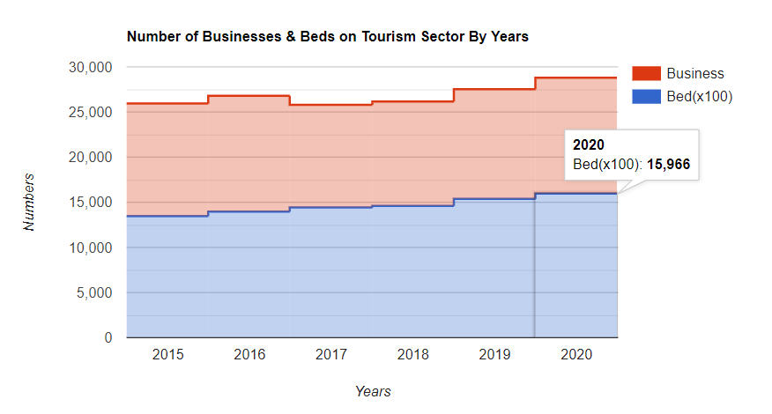

On the chart, although there have been fluctuations in the last 6 years, there is a steady rise. During the pandemic period, we can see both the number of businesses and the number of beds increase. The reasons mentioned earlier is also valid for the increase in the number of operations and beds during the pandemic. When the data for 2021 is shared, we will also see the effects of this year.

If we look at the effects of the COVID19 pandemic on workers working in the tourism sector, we will refer to the number of employees in various sectors related to tourism in the chart below and the changes in these numbers in the last three years.

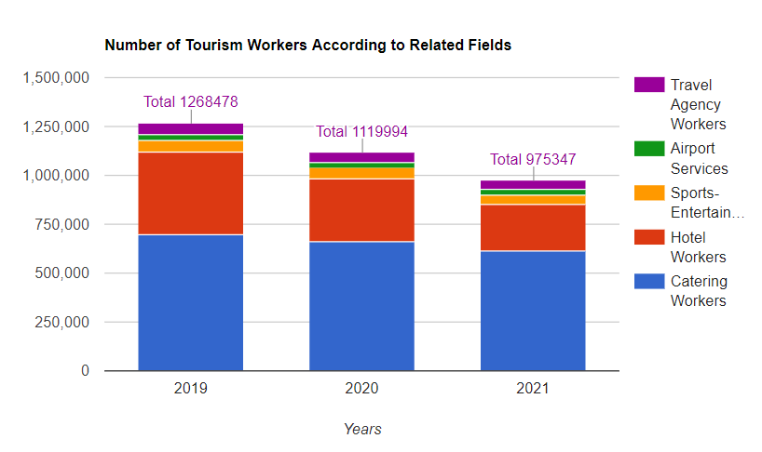

Looking at the chart, based on the data we mentioned in the previous part, we see that the number of workers working in the tourism sector decreased clearly during the pandemic period. In 2019, the year before the pandemic, the number of workers working in the tourism sector decreased from 1.26 million to 975 thousand in 2021. At this point, we can assume that, as we mentioned in the previous section, there was no serious decrease in the number of businesses and beds in 2020 and there was a slight increase. What we want to say here is that businesses may have employed workers in order to reduce their own expenses. During the first initial period of the pandemic, workers may have been terminated while there was no restriction on the removal of workers by the state. In addition, because many of the workers in the tourism sector work seasonally, they may have easily been exempt from the state-created employee removal barrier. As we have already mentioned, we are still in the year 2021, and this data was obtained only from the first quarter of 2021. According to the measures taken in the summer of 2021, there may be a movement in the tourism sector and the employment rate in tourism may increase again. By the end of 2021, we will be seeing the impact of the pandemic on tourism workers much more clearly. Finally, in order to show the relationship between the number of enterprises operating in the tourism sector and the number of tourism workers in the last three years, the following chart has been created.

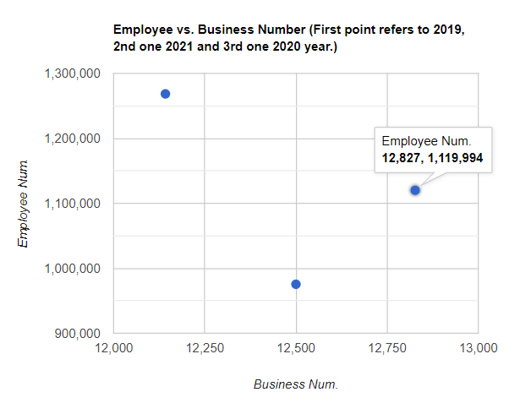

As we have already mentioned, there may be unexpected results among the data. For example, the number of workplaces may increase, while the number of employees may decrease. In addition, since the number of enterprises data for 2021 has not yet been published, the estimated figure has been taken compared to the previous year and according to forecasts made during the course of the epidemic.

In conclusion, looking at all these data and charts, we again understand that the COVID19 epidemic is a large-scale crisis for Turkey as well as for the whole world. Although many people have changed their habits, one of their biggest effects has been in the field of travel. This has directly affected the tourism sector, which is one of the largest foreign exchange sources in Turkey. Many tourism related data, such as number of people visiting Turkey, their visiting periods, tourist numbers from different countries, the amount of income from tourism, expenditure amounts for tourism, the number of businesses operating in the tourism sector, unemployment rates in the tourism sector, number of tourism agencies etc., have suffered serious damage and many have fallen to their lowest levels in recent years. The tourism sector, which has suffered so much in the first year and a half of the pandemic, will face very serious problems if conditions continue in this way. Many tourism businesses that try to maintain their operations under difficult conditions are closing or going bankrupt. In this regard, new measures should be taken, and incentives should be provided for tourists coming from inside and outside Turkey. Finally, encouraging tourists to come to our country with reassuring advertising would be the right step in this understanding.

**References**

* Turkish Statistical Institute(TUIK); Education, Culture, Sports and Tourism Statistics.

Website: <https://data.tuik.gov.tr/Kategori/GetKategori?p=egitim-kultur-spor-ve-turizm-105&dil=1>

* Republic of Turkey Ministry of Culture and Tourism General Directorate of Investments and Enterprises.

Website: <https://yigm.ktb.gov.tr/TR-9851/turizm-istatistikleri.html>

* Association of Turkish Travel Agencies; Tourism Reports and Statistics.

Website: [https://www.tursab.org.tr/istatistikler/turizmin-ekonomideki-yeri#](https://www.tursab.org.tr/istatistikler/turizmin-ekonomideki-yeri)

* Tourism Data Bank; Statistics & News.

Website: <https://www.turizmdatabank.com/>

* Tourism Diary: Tourism and Travel Newspaper; News.

Website: <https://www.turizmgunlugu.com/>

* Hotel Association of Turkey.

Website: <http://www.turob.com/tr>

1. This year, there are unusual political conditions and terrorist attacks in our country. Accordingly, it has created question marks for our guests who will be involved in tourism activities. This is also reflected in the data.